5.Write a Pandas program to create a bar plot of the trading volume of Alphabet Inc. stock between two specific dates.
Aim:
To write a Pandas program to create a bar plot of the trading volume of Alphabet Inc. stock between two specific dates.
Program:
import pandas as pd
import matplotlib.pyplot as plt

data = pd.read_csv("alphabet_stock.csv")

data["Date"] = pd.to_datetime(data["Date"])

filtered = data[(data["Date"] >= "2024-01-02") & (data["Date"] <= "2024-01-06")]

plt.bar(filtered["Date"], filtered["Volume"])
plt.title("Alphabet Inc. Trading Volume")
plt.xlabel("Date")
plt.ylabel("Trading Volume")
plt.xticks(rotation=45)
plt.show()

Output:
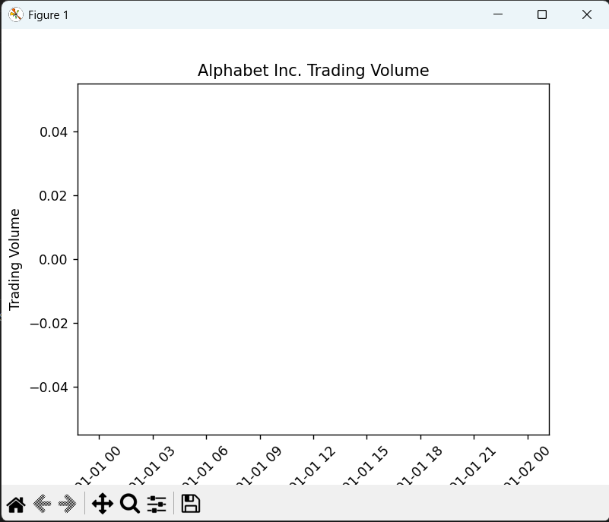
Result:
The program successfully created a bar plot of the trading volume of Alphabet Inc. stock between the specified dates.

6.Write a Pandas program to create a scatter plot of the trading volume/stock prices of Alphabet Inc. stock between two specific dates.
Aim:
To write a Pandas program to create a scatter plot of the trading volume and stock prices of Alphabet Inc. stock between two specific dates.
Program:
import pandas as pd
import matplotlib.pyplot as plt
data = pd.read_csv("alphabet_stock.csv")
data["Date"] = pd.to_datetime(data["Date"])

filtered = data[(data["Date"] >= "2024-01-02") & (data["Date"] <= "2024-01-06")]
plt.scatter(filtered["Volume"], filtered["Close"])
plt.title("Alphabet Inc. Stock Price vs Trading Volume")
plt.xlabel("Trading Volume")
plt.ylabel("Stock Price")
plt.show()
Output:
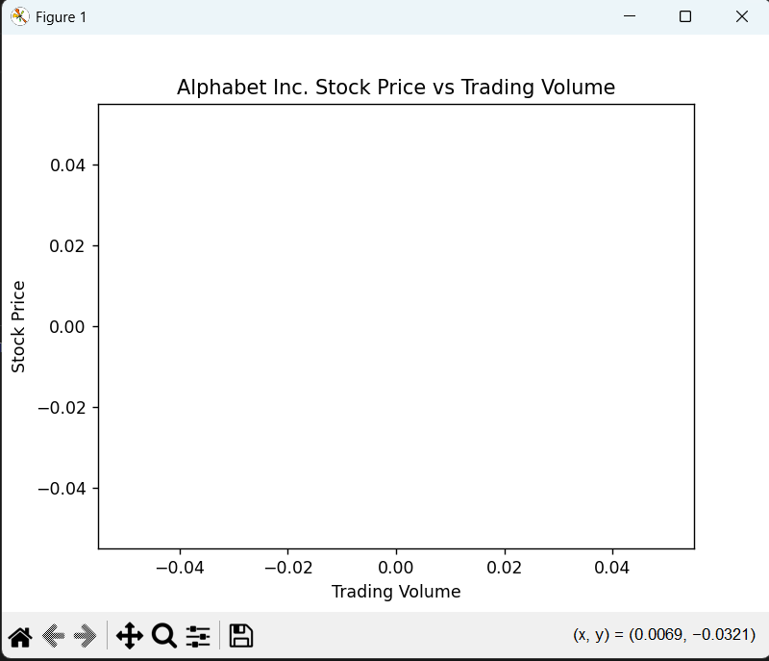

Result:
The program successfully created a scatter plot of the trading volume and stock prices of Alphabet Inc. stock between the specified dates.

